40.17: Since 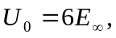 we can use the results from Section 40.3, 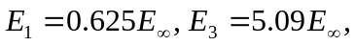 and
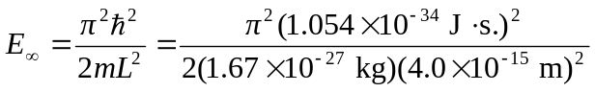
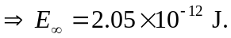
The transition energy is
The wavelength of the photon absorbed is then
